
Hkkjrh; izkS|ksfxdh LkaLFkku iVuk
Indian Institute of Technology Patna
Department of Electrical Engineering
IIT Patna, Campus, Bihta, Patna, Bihar – 801103 Experiment No:-2

DIODE CIRCUITS

OBJECTIVES: Design and analysis of half wave rectifier and clipping circuits.

MATERIALS REQUIRED

- Components :
Diode : One: Type 1N4007
Zener Diode : One: (voltage VZ = 3.3 V)
Resistance : Five: 470 Ω, 56 Ω, 1 KΩ, 2.2 KΩ, 4.7 KΩ
Capacitor : One: 22 µF25V.

GENERAL GUIDELINES / PREQUATIONS

1. Connect the capacitor with correct polarity. The capacitor being of electrolytic type, it is polarized, and will be damaged if connected with incorrect polarity. Similarly, confirm the polarity of the diodes before connecting.

2. Keep ground terminals of oscilloscope probes and function generator output connected together throughout the experiment.

3. In an oscilloscope, for higher precision, increase vertical sensitivity (i.e. lower value of volt/div), especially while measuring small amplitude levels (e.g. ripple voltage). You may need to switch to ac coupling while doing so.

PART A : HALF - WAVE RECTIFIER WITHOUT FILTER

1. Set the function generator to get 10 V peak-to-peak sine wave (in High Z load mode) at 500 Hz frequency. Do not connect any circuit to the function generator. Keep dc offset equal to 0. Observe the function generator output on the oscilloscope and verify sine wave generation.

2. Set up the circuit as shown in Fig. 2.1(a) without the capacitor C, taking RL = 2.2 kΩ.

3. Now, connect the function generator to the circuit at points F1 & F2 as shown in Fig. 2.1(a).

4. Display Vi and Vo simultaneously on the oscilloscope. Sketch Vi and Vo one below the other with identical time and amplitude axes.
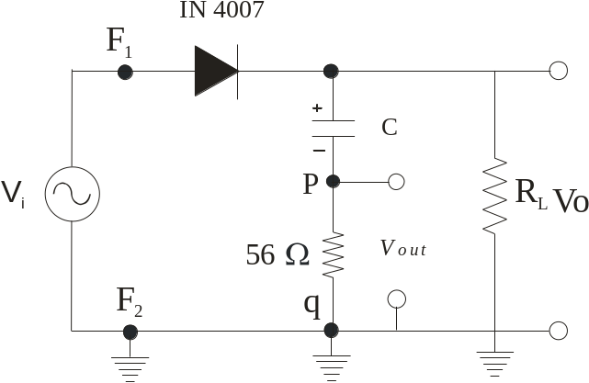
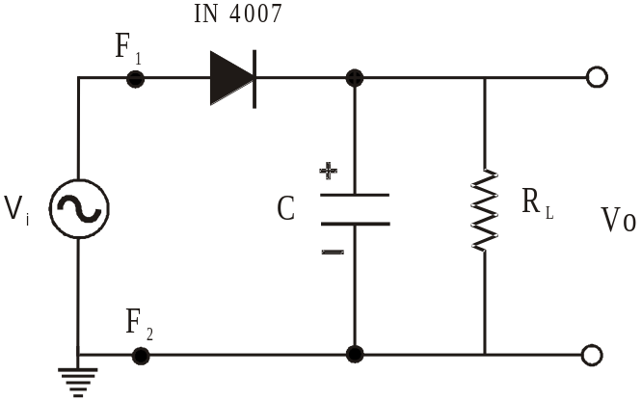

(a) (b)

Fig. 2.1 Half-wave rectifier

PART B: HALF - WAVE RECTIFIER WITH CAPACITOR FILTER

1. Now connect a capacitor C = 22 µF in the circuit with correct polarity as shown in Fig. 2.1(a).

2. Display Vi and Vo simultaneously on the oscilloscope. Sketch Vi and Vo overlapping, with the same time and amplitude axes.

3. Measure peak-to-peak ripple voltage on oscilloscope by enlarging Vo to the maximum extent. You may have to put the input coupling in ac mode while doing this measurement. See the guidelines given at the end.

Repeat steps 2 and 3 for RL = 2.2KΩ and 4.7 KΩ. Comment on the output waveforms and ripple voltages.

4. Connect a 56Ω resistance in series with C of Fig. 2.1(a) as shown in Fig. 2.1(b). The points across this 56Ω resistor are marked as p and q.

Please note that: The resistance 56Ω is chosen small enough not to affect the overall performance of the circuit and at the same time to ensure an appreciable voltage across it. This voltage represents the current flowing through the capacitor.

5. Display and sketch Vo and V56 (i.e. voltage across 56Ω between ‘p’ and ‘q’) one below the other with identical time axes. Mark the ground reference line.

Q. 1: Why is I_{C} (=V_{470Ω} / 470 Ω), the current through the capacitor, negative for some portion of a cycle? Estimate I_{surge} (positive peak of IC).

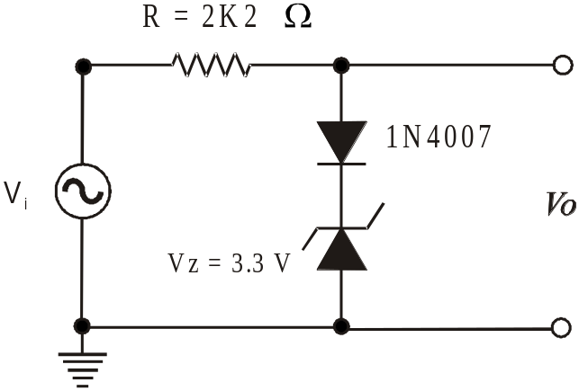PART C : CLIPPING CIRCUIT - POSITIVE CLIPPER

1. Connect the circuit as shown in Fig. 2.2 with
R = 2.2 KΩ
2. Set the function generator to get 10 V peak-to-
peak sine wave (in High Z load mode) at
500 Hz frequency. Observe the function generator
output on the oscilloscope and verify sine
wave generation.

3. Connect the function generator output to the
circuit as shown in Fig. 2.2.

4. Display and sketch Vi and Vo one below the other with identical time and amplitude axes.

5. Superimpose the two waveforms Vi and Vo and Fig. 2.2 Positive clipper
observe

6. Set the oscilloscope in X-Y mode (Vi to Ch2 : X- input and Vo to Ch1 : Y-input) and sketch Vo versus Vi with equal x and y scales. Label the graph and ticks on the axes.

Q. 2: Draw the circuit diagrams for: (a) –ve clipper (b) +ve and –ve clipper

Pre observation reading:
(a) Draw the expected waveforms at –
(i) Step no. 4 of PART A, (ii) Step no. 2 of PART B and (iii) Step no. 4 of PART C.

Q.3: Why electrolytic capacitor has polarity.

